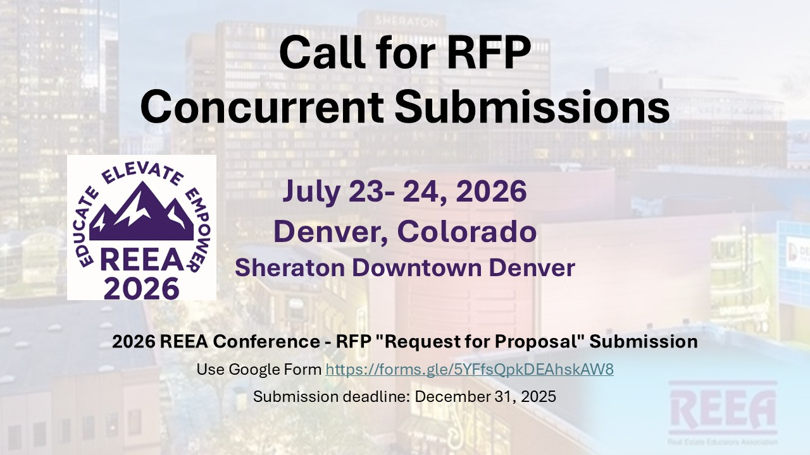
Use this link to submit your RFP before December 31, 2025.
https://forms.gle/ZopCfwWtryHCHDjD9

